**Welspun Global Service**

Survey No. 76, Village Morai, Vapi, District Valsad, Gujarat 396191, India.

**Entity: WGBL**

**TOOL DOCUMENT**

**A.1 Disclaimer:**

This document has been prepared based on information/data provided by WGBL. The document may be optimized or changed based on more information provided by WGBL. Welspun Global Services does not assume any responsibility for inaccuracies, errors, or omissions that may be contained herein. In no event will Welspun Global Service be held liable for direct, indirect, special, incidental, or consequential damages resulting from any defect or omission in this document or/and the solution, even if advised of the possibility of such damages.

Welspun Global Service is space of Consulting and Solution Provider and does not have any control on product, Technology or Solution offered by Automation Anywhere and hence will not be liable for any defect, issues, loss of business, damages faced by customer for problems related to Product, Technology and Support offered by Automation Anywhere. We have shared overall requirement and current setup details with Automation Anywhere and the proposed solution is in line with their recommendation.

The solution referred to in this document has been designed as per Welspun Global Service understanding of the Customer's overall solution requirements. The performance of individual components therein may differ when functioning as part of the overall solution as compared to what the individual component is capable of delivering. Welspun Global Service hereby disclaims warranty on the performance of the individual components in the above circumstances.

A.2 Process Name: Price & characteristic approval tool

A.3 Process overview

In this process change approval for MRP, SP, Cost, HSN & others are taken from predetermined approvers & once it is approved the changes are executed by MDM team. Currently all this process is done on mail. The same process will be done through tool.

A.4 Process Scope

This process is done for WGBL entity

A.5 Process Description

|  |  |  |
| --- | --- | --- |
| Sr. No. | Particulars | Details |
| 1 | Process Name | Price & Characteristics Approval Tool |
| 2 | Development Initialization date |  |
| 3 | Complexity | Medium |
| 4 | SSC Head | Mr Nitin Jain |
| 5 | Project Manager | Mr Saurabh Verma |
| 6 | Project Lead | Ms Bhagyashri Wayare |
| 7 | Process Owner | Mr Sanjeet Gupte |
| 8 | Activity Owner | Mr Salin Nair |
| 9 | Developer Lead |  |

A.6 Document history

|  |  |  |  |  |  |
| --- | --- | --- | --- | --- | --- |
| Version | Created/ Updated by | Creation/ Updation date | Changes done | Signed off by | Signed off date |
| Base Version | Anup Gupta | 18 January 2023 | Base version | Salin Nair | 20 Jan 2023 |
| V1.0 | Anup Gupta | 23 Jan 2023 | Addition of business type | Sanjeet Gupte | 23 Jan 2023 |

A.7 Current environment

* Initiator will send the details & attachment for which changes has to be done through mail.
* Details will be sent for approval, according to approval matrix.
* Details is sent to MDM person once all the approvals is received.
* MDM team member will make the changes & confirm it on mail.

A.8 Applications used in current process

|  |  |  |
| --- | --- | --- |
| Sr. No | Current sources | Application/ file/ path |
| 1 | Outlook | All the details are shared for approval through mail & approval is also received through mail |

A.9 Process As Is

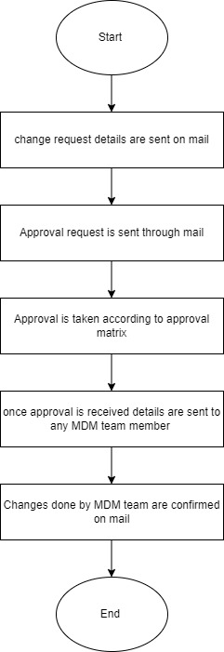

A.10 Process use cases

* Initiator will fill the changes details in tool
* Submit it for approval.
* Details & attachment will be sent for approval according to approval matrix.
* After approval details will be sent to MDM team member
* MDM team member will update for same through tool

A.11 Process To Be

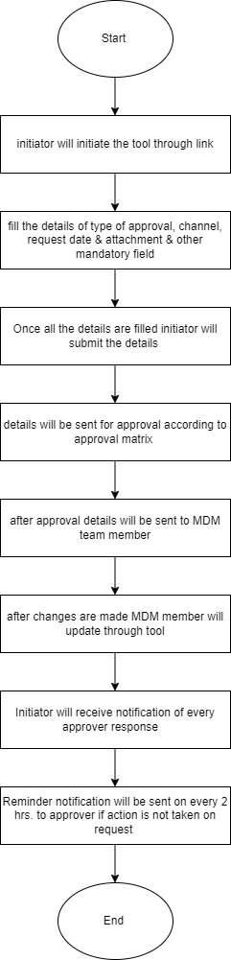

A.12 Applications used in process

|  |  |
| --- | --- |
| Sr. No | Applications |
| 1 | Power App |
| 2 | Power automate |
| 3 | Share point |
| 4 | One drive |

A.13 Tool description

|  |  |
| --- | --- |
| Sr. No | Fields |
| 1 | Tool will contain two screen   * Request creation: through this Tab initiator will initiate changes request * Dashboard: here power BI dashboard will be there which will reflect request raised through tool, status of request. Logs can be downloaded from dashboard in excel format. |
| 2 | **Request creation screen**  This screen will contain mandatory fields which initiator will fill.   * **Business type**: it will contain below mentioned drop down * B2B * B2C * **Type of approval**   It will contain below mentioned drop downs   * MRP * SP * Characteristics * Cost/ MRP * HSN * Article description * others * **Channel**   If business type selected is B2C, It will contain below mentioned drop downs.   * SIS * SND * ECOM * S&D W * Stores * ALL   If business type selected is B2B, It will contain below mentioned drop downs   * ALTPL * Institution * Hospitality * CSD * **Request date**: This will be auto generated. Here date of request initiation will appear automatically. * **Attachment**: here initiator will enter attachment. All the attachments sent through tool will be saved in one drive in year, month & date format. * There will be three attachment option. Plant approval, plant costing/ outsourcing, others. Attaching all the three attachment will not be mandatory. * **Reason**: This will be text field. Here initiator will mention the reason for change request. * **Initiator Email id**: here initiator of request will enter his email id. * **Executioner Email id**: here MDM email id will appear in Drop down. [mdm_cell_vapi@welspun.com/](mailto:mdm_cell_vapi@welspun.com/) [bimlesh_jha@welspun.com](mailto:bimlesh_jha@welspun.com).   Initiator will select from email id drop down.   * Submit: through this Tab initiator will submit the details & it will be sent for approval. |
| 3 | * **Approval matrix for B2C business type** * Details will be sent according to below approval matrix   **Approver 1**   * Approval request will be sent to [salin_nair@welspun.com/](mailto:salin_nair@welspun.com/) [amit_dive@welspun.com](mailto:amit_dive@welspun.com). * If approval is received from any one than it will be sent to next level for approval.   **Approver 2**   * Approval request will be sent to [jai_bihani@welspun.com/](mailto:jai_bihani@welspun.com/) [ashish_sharma@welspun.com](mailto:ashish_sharma@welspun.com) * If approval is received from any one than it will be sent to next level for approval.   **Approver 3**   * Approval request will be sent to [sanjeet_gupte@welspun.com/](mailto:sanjeet_gupte@welspun.com/) [kapil_bhatia@welspun.com/](mailto:kapil_bhatia@welspun.com/) [jashan_rajpal@welspun.com](mailto:jashan_rajpal@welspun.com) * If approval is received from any one then it will be sent to next level for approval. |
| 4 | * **Approval matrix for B2B business type** * Details will be sent according to below approval matrix  1. For AltPL channel approval matrix will be as below  * Approver 1   Approval request will be sent to[umashankar_khemka@welspun.com](mailto:umashankar_khemka@welspun.com)   * If approval is received then it will be sent to next level for approval. * Approver 2   Approval request will be sent to [sanjeet_gupte@welspun.com/](mailto:sanjeet_gupte@welspun.com/) [kapil_bhatia@welspun.com/](mailto:kapil_bhatia@welspun.com/) [jashan_rajpal@welspun.com](mailto:jashan_rajpal@welspun.com)   1. For Institution channel approval matric will be as below  * Approver 1   Approval request will be sent to [shriramachandra_soratur@welspun.com/](mailto:shriramachandra_soratur@welspun.com/) [puneesh_jhandai@welspun.com](mailto:puneesh_jhandai@welspun.com)   * If approval is received from any one then it will be sent to next level for approval. * Approver 2   Approval request will be sent to [sanjeet_gupte@welspun.com/](mailto:sanjeet_gupte@welspun.com/) [kapil_bhatia@welspun.com/](mailto:kapil_bhatia@welspun.com/) [jashan_rajpal@welspun.com](mailto:jashan_rajpal@welspun.com)   1. For hospitality channel approval matrix will be as below  * Approver 1   Approval request will be sent to  [beenu_singh@welspun.com/](mailto:beenu_singh@welspun.com/) [shriramachandra_soratur@welspun.com/](mailto:shriramachandra_soratur@welspun.com/) [puneesh_jhandai@welspun.com](mailto:puneesh_jhandai@welspun.com)   * If approval is received from any one then it will be sent to next level for approval. * Approver 2   Approval request will be sent to [sanjeet_gupte@welspun.com/](mailto:sanjeet_gupte@welspun.com/) [kapil_bhatia@welspun.com/](mailto:kapil_bhatia@welspun.com/) [jashan_rajpal@welspun.com](mailto:jashan_rajpal@welspun.com)   1. For CSD channel approval matrix will be as below  * Approver 1   Approval request will be sent to [shriramachandra_soratur@welspun.com/](mailto:shriramachandra_soratur@welspun.com/) [puneesh_jhandai@welspun.com](mailto:puneesh_jhandai@welspun.com)   * If approval is received from any one then it will be sent to next level for approval. * Approver 2   Approval request will be sent to [sanjeet_gupte@welspun.com/](mailto:sanjeet_gupte@welspun.com/) [kapil_bhatia@welspun.com/](mailto:kapil_bhatia@welspun.com/) [jashan_rajpal@welspun.com](mailto:jashan_rajpal@welspun.com) |
| 5 | **Approve/ reject**   * If the details will be approved from previous level then only it will go ahead for approval. * If request gets rejected at any level then it will not move ahead for approval. * Initiator will get notification in case of approval or rejection according to approver action & also he will get to know at what level approval is pending. It will also include date of approval/ rejection at each level. * Reason option: it will be provided to approver & he will mention the reason for approval if required, but it will be necessary for approver to enter reason for rejection of request. |
| 6 | * Once the request is approved details with attachment will be sent to executioner (MDM team) whose email id is entered by initiator in request screen. * **Executioner** * Executioner will be provided with Submit & close and reject option through which he will intimate about his action. * This intimation will be sent to initiator of request & approver 1 through auto mail. |
| 6 | **Default reminder**  Reminder will be sent to approver after every 8 hours by default for his action on request raise for changes.  **Customize reminder** option will also be given in tool by which requester can send reminder according to them. |
| 7 | **Status**  There will be three status in tool according to approval.   * **Pending:** if request is generated & sent for approval & approval is pending then status will be pending. * **Approved:** if request get approved at all level then status will be approved. * **Rejected:** if request gets rejected at any level then status will be rejected**.** |